Radium Sorption to Iron (hydr)oxides, Pyrite, and Montmorillonite: Implications for Radium Transport

Michael A. Chen and Benjamin D. Kocar*

Dept of Civil and Environmental Engineering,

Massachusetts Institute of Technology

*Corresponding author, kocar@mit.edu

**Abstract**

Radium (Ra) is a radioactive element commonly found within soils, sediments and natural waters. Elevated Ra activities arising through natural and anthropogenic processes pose a threat to groundwater resources and human health, and Ra isotope ratios are used to decipher groundwater movement, estimate submarine discharge flux, and fingerprint contamination associated with hydraulic fracturing operations. Although transport and retention of Ra within subsurface environments is known to be dominated by adsorption, particularly by metal (hydr)oxides, there is limited understanding of how Ra associates with other mineral surfaces. Here, we present results of sorption studies and surface complexation modeling of Ra to ferrihydrite, goethite, montmorillonite, and pyrite, in a low salinity groundwater solution across a range of pH values. We find that ferrihydrite and goethite are major sorbents of Ra at neutral to basic pH, but that (sodium) montmorillonite retains comparatively more Ra across a wide range of pH values (normalized to either mass or surface area), owing to interlayer ion exchange. When normalized to surface area, pyrite retains the most Ra at pH 7 and 10 of all minerals examined. The results here highlight the key role of redox- conditions and associated mineralogical alterations on Ra mobility, and provide surface complexation parameters for informing models used to predict Ra transport in soil and sedimentary systems.

**Introduction**

Chronic ingestion and inhalation of radioactive materials, including radium (Ra) and radon (Rd), represents an ongoing threat to human health worldwide.1 Of these, Ra is ubiquitous in soils, aquifers, and natural waters owing to the radioactive decay of primordial 235U, 238U, and 232Th, and often accounts for the dominant fraction of total radiation found in groundwater. All isotopes of Ra are unstable, and four (223Ra, 224Ra, 226Ra, and 228Ra) possess half-lives sufficient to persist within environmental systems and present a risk for human exposure. Moreover, 226Ra (half-life of 1600 years) is the parent radionuclide of 222Rn; chronic inhalation of 222Rn is a major driver for increased risk of lung cancer. Hence, geochemical controls on Ra mobility are directly tied to the mobility and accumulation of Rn within soil-sedimentary systems.2

Several geochemical processes impart overarching controls on Ra within soils and aquifers. Alpha-recoil, the ejection of daughter radionuclides from soil and sedimentary minerals into adjacent porewater, is the primary process sourcing Ra to groundwater. Ongoing alpha recoil progressively elevates porewater Ra activities until hydrologic flushing removes the equilibrating solution, or Ra achieves secular equilibrium with its parent radionuclides. Most aquifer systems contain low (e.g. U, Th, <5 mg/kg) but adequate parent radionuclide and sufficiently favorable hydrological conditions to facilitate delivery of measurable Ra to solution.3 In a recent USGS study, 3% of groundwater samples (n=1270) within 7 of 15 principal US aquifers exceeded the USEPA limit for total Ra of 0.185 Bq/L.4 Further, high levels of Ra are often present with deeper formations, particularly shales, where low groundwater flux yield potentially hazardous activities (0.102-343 Bq/L).5 These naturally elevated Ra bearing formations are prevalent in some parts of the US (PA, WY, TX) and abroad (Middle East, etc.). 6,7 Anthropogenic activities, including uranium mining and hydraulic fracturing, can redistribute Ra and other constituents of naturally occurring radioactive materials (NORM), posing potential hazard to soils, surface waters, and aquifers.

While Ra transport is considered to be conservative in some groundwater systems, it nevertheless participates in geochemical reactions that may alter its subsurface distribution. In general, Ra mobility within most natural systems is not thought to be influenced by precipitation (or co-precipitation)-dissolution of Ra-bearing solids.1,8 Instead, Ra sorption to solids, particularly mineral surfaces, imparts the greatest chemical control on soluble Ra transport in groundwater systems.9 Under environmental conditions, Ra is not redox active, and its solution speciation is dominated by free Ra2+ across a wide range of chemical conditions (e.g. pH and salinity). Weak complexes with carbonate, sulfate, and chloride are observed, but these solution species dominate at extremely acidic or basic pH values and when ligand activities exceed environmentally relevant activities.10

Soil and sedimentary minerals known to sorb appreciable quantities of Ra include metal (hydr)oxides and 2:1 clays with an exchangeable interlayer. However, previous data are primarily derived from Ra sorption experiments using mineralogically heterogeneous soil and sedimentary solids under a single geochemical condition. This has generated a wealth of reported Kd values for Ra sorption to different soil and aquifer materials, but is of limited use when predicting Ra mobility under different or varying geochemical conditions. Moreover, few studies have examined or predicted mechanisms of Ra sorption, which may aid in predicting mobility under a range of geochemical conditions. One study used surface complexation modeling (SCM) to examine Ra adsorption to metal (hydr)oxides, but at levels far exceeding those found in most environmental systems, and was limited to Fe (hydr)oxides (goethite and ferrihydrite). 11,12 There is also a paucity of data regarding Ra adsorption to redox-sensitive minerals found under anoxic or reducing conditions. These solids, including metal sulfides such as pyrite, may be particularly important within soil and aquifer systems derived from shale, and also within marine sediments—including those which intercept submarine groundwater discharge.

Improved knowledge of Ra sorption to common soil and sedimentary solids is required to decipher and predict Ra mobility and total activities within natural waters, and may aid in interpreting Ra isotopic ratios. The objectives of this study were to therefore 1) examine and compare low-activity Ra adsorption to ferrihydrite, goethite, and Na-montmorilonite—minerals known or inferred to control Ra transport over a range of solution conditions found in soils and aquifers—and pyrite, a mineral commonly found within reduced and anoxic soils and sediments, and 2) use SCM to constrain Ra adsorption mechanisms and provide a quantitative basis for comparing Ra adsorption to different minerals, across a range of pH values. We illustrate that Ra adsorption to montmorillonite is more extensive over a range of solution conditions compared to iron (hydr)oxides, which are often thought as dominant Ra sorbents. Further, we find that under neutral or high pH, Na-montmorillonite retains the most Ra of all minerals tested on a mass basis, but adsorption to pyrite far exceeds all other minerals when normalized to surface area. In accordance with other studies, we find that pH plays a crucial role in determining the extent of Ra sorption to most mineral surfaces; Ra adsorption to Fe (hydr)oxides and pyrite is extensive at neutral to high pH, yet limited under acidic conditions.

**Materials and Methods**

Dissolved 226Ra stock in 3% HCl was provided by the MIT Environmental, Health, and Safety office and used for all experiments. A ferrihydrite slurry and goethite powder were prepared using standard methods and added to the experiments.13 Powdered calcium montmorillonite STX-1b was ordered from the clay minerals society (clays.org), re-equilibrated with sodium chloride to allow for closer comparisons to previous studies of Ra sorption to Na-montmorillonites, and then cleaned of carbonates using standardized techniques.14 Pyrite was ordered from Ward’s Science (www.wardsci.com), ground using mortar and pestle, passed through sieves to select for 45-250 um particles, and transferred to an anaerobic glove bag (5% H2: 95% N2: < 1 ppm O2). It was then washed in 6 N HCl overnight to dissolve any oxidized coatings, rinsed with deoxygenated DI water three times to remove residual acid, and dried anaerobically at room temperature in an open beaker. The composition of pyrite, ferrihydrite and goethite was confirmed using XRD, and surface area was measured for all minerals using BET (table S1). Further information about mineral preparation can be found in the supporting information.

Isotherms were conducted using serum vials (200 mL) filled with 100 mL of 10 mM NaCl stock solution, 30 mg of a single mineral (except for the case of pyrite, where 40 mg was used), and 5-270 Bq of 226Ra stock. Experiments using pyrite were performed in an anaerobic glove bag, and all solutions were purged with N2 prior to placement in the anaerobic chamber. The pH was titrated to 3,5,7 or 9 +/- 0.05 through use of an autotitrator, and the bottle was sealed with a thick butyl stopper. Bottles were shaken for 24 hours to allow sufficient time for sorption equilibrium.11 A kinetic study of Ra adsorption to montmorillonite confirmed 24 hours is sufficient to achieve equilibrium. pH was readjusted after equilibration if necessary; details on this process are in the supporting information. Acid (HCl) and base (NaOH) volume additions did not exceed 5% of the original volume. Once re-titration and re-equilibration were complete, samples were filtered using 0.22 µm PES filters, which did not sorb significant quantities of Ra. Experimental error was quantified by measuring the standard deviation of triplicates for each data point.

**Analytical Techniques.** Solutions of Ra were quantified using scintillation counting. Up to 10 mL of sample were mixed with 10 mL of Ultima Gold XR (Perkin Elmer) and sealed for 30 days to allow 226Ra to reach secular equilibrium with its daughter products. The equilibrated samples were then counted using a Beckman Coulter LS 6500 scintillation counter, and the resulting counts were compared to a calibration curve of similarly prepared 226-Ra standards to determine solution activities. This was sufficient to determine the extent of sorption and develop isotherms, with the single exception of experiments using ferrihydrite at pH 9, where gamma spectroscopy was used to quantify Ra. Details of the gamma spectroscopy and 226Ra standards are in the supporting information.

**Surface Complexation Modeling.**

Radium interaction with mineral surfaces was modeled through a double diffuse layer (DDL) surface complexation model implemented in PHREEQC.16 Reaction formulations developed from spectroscopic measurements and used in previous studies were used to fit the experimental data.11,12 Details for fitting SCMs here along with some alternative modeling strategies are found in the supporting information.

**Results and Discussion**

**Sorption isotherms.** All fitted isotherms were linear within the range of activities studied, and a Kd value was calculated by fitting a line to the experimental data (Table 1). The sorption isotherm results for all minerals (normalized by mass) are plotted in figure 1. Sorption to both iron oxides show a strong dependence on pH, with ferrihydrite showing greater sorption across all pH values compared to goethite, and the extent of sorption increasing with increasing pH for both iron oxides. Differences in the surface area (table S1) explain some of the variation when comparing the extent of Ra sorption for goethite and ferrihydrite sorption, with ferrihydrite having nearly twice the surface area of goethite. Accordingly, A Ksa, defined as the Kd normalized by the mineral surface area (m2/g) (table 1), is used to compare the extent of Ra adsorption between treatments. At circumneutral pH, goethite and ferrihydrite have relatively close Ksa values, however at more extreme values (pH = 3 and pH = 9), ferrihydrite demonstrates an appreciably larger extent of sorption compared to goethite. Two studies report isotherm data for Ra sorption to ferrihydrite, and the experimental results presented here match both reported values to within an order of magnitude of the Kd values.11,17 The K­d found in our study is the largest of the collected data sets, but was also performed at lower background ionic strength (here, 10 mM, others, 100-500 mM) and higher mineral surface area (here, 382.9 m2/g, others, ~250 m2/g) , consistent with previous results suggesting increased salinity reduces the extent of Ra sorption.9 One study compared Ra sorption to hematite, ferrihydrite, goethite, and lepidocrocite, finding that ferrihydrite sorbs Ra most extensively.17 This suggests the sorption isotherm results presented here represent an upper limit for Ra sorption to iron oxides in these conditions.

Reported Kd values for Ra adsorption to goethite (and experimental conditions) vary widely (table S2).11,17,19 Unlike results obtained for ferrihydrite, we observe a larger extent of Ra sorption at pH 7 and 9, which may be attributed to differences in solution ionic strength and surface area of the synthesized goethite. When normalized by surface area, Kd values are similar in some cases,11 but are different in others where ionic strength was much higher.17 Although the goethite synthesized here should more closely match those found in natural settings,13 other studies used different synthesis methods that often result in lower surface area. The differences between the results here and in other studies underscore the limitations of using Kd to describe and report solute-solid interactions.

Sorption isotherm results for Ra onto sodium montmorillonite are plotted in figure 1, the calculated Kd and Ksa values listed in table 1. With the exception of ferrihydrite at pH 9, the total extent of sorption to montmorillonite is larger than iron (hydr)oxides over all pH values. Also, a comparatively weaker pH dependence is observed for montmorillonite sorption. This result suggests that the dominant mechanism controlling montmorillonite sorption is not complexation with pH dependent surface (edge) functional groups, but rather exchange of Ra with ions in clay interlayer. Comparison of the measured sorption Kd values here to earlier studies reveal appreciable differences, with values spanning approximately one order of magnitude (table S2). Those using a high solid-solution ratio (3000-50000 mg/L) resulted in less sorption compared to the sorption results found here, which used only a 300 mg/L solid-solution ratio.14,20 The CEC of the montmorillonites are similar to that used in this experiment (within 10 meq/100 g clay), and albeit higher here, surface areas are within a factor of three of each other, suggesting interlayer charge is also similar.

Pyrite showed limited sorption of Ra at low pH (3 and 5), but appreciable sorption at higher values, with little difference observed between isotherms performed at pH 7 and 9 (figure 1). The circumneutral and basic Kd values (table 1) for pyrite are comparable to that of goethite at a circumneutral pH. Unexpectedly, calculated Ksa values show that pyrite has the largest sorption of all of the minerals considered here. There is very little, if any existing data examining the sorption of Ra to any reduced iron solid. A previous study demonstrated that strontium, which possesses analogous geochemical characteristics as Ra, did not sorb extensively to pyrite22, but little other data exists regarding group II cation sorption to unoxidized pyrite surfaces. In contrast, a variety of experimental and spectroscopic techniques to study redox active metal ions sorption to the pyrite surface, which often includes redox reactions between the metal ion and pyrite surface groups.10–16 The results of these studies imply that redox active metal ions or trace quantities of dissolved oxygen in solutions with Ra may alter the pyrite surface, consequentially diminishing or enhancing Ra sorption. However, we find no evidence of (oxic) pyrite alteration in our experimentation, and exceedingly low concentrations (0.06-31 nmoles per experiment) preclude other methods for examining the coordination environment of adsorbed Ra. The results here suggest that reduced iron solids may play a key role in anoxic aquifers, and redox-induced mineralogical alteration may diminish or enhance Ra retention.

**Surface Complexation Modeling**. Radium adsorption to ferrihydrite and goethite was simulated using two tetradentate reactions with a single site based on SCM by Sajih, 2014, closely match the experimental data (figure 2). A simpler, non-electrostatic formulation that can be compared to other studies of metal sorption was also examined, but had worse apparent fits (see supporting information). The fitted reactions and constants (table 2) show that ferrihydrite and goethite have roughly similar reaction constants, but ferrihydrite has more sites, explaining the greater observed sorption extent. While the reaction constants found here are only a few log units larger than other studies’ goethite results, the constants for ferrihydrite sorption reactions here are nearly 20 log units smaller.11,12 Although this disparity is quite large, it is known that the structural properties (crystallinity, crystal unit size, water content) of ferrihydrite may vary substantially according to the method used for synthesis, which may account for some of the variance.23

Concentrations of Ra used here are far below the analytical detection limits of techniques used to describe and constrain the bonding environment of Ra to solids. Hence, SCM developed here for Ra adsorption is compared with other studies that combine SCM with spectroscopic measurements, which were used to constrain surface reactions of other group 2 elements. Surface site reactions involving these other elements may have similar coordination environment and complexation reactions with solid surfaces. X-ray absorption spectroscopy was used to examine Sr binding with the surface of iron (hydr)oxides, and revealed that it forms outer sphere complexes.24 A separate study used SCM informed by x-ray spectroscopy to constrain group II element sorption to iron (hydr)oxides, suggesting Ra had tetradentate coordination with iron (hydr)oxide surface sites.12,25 Fitted reaction constants here, and for Sr surface complexation,26 however, have not closely matched the constants predicted by that study.12 A problem that arises when comparing SCM results is that multiple reaction formulations can satisfy the constraints developed by spectroscopic observations, without a clear indication as to which is a more accurate description of sorption or if those constraints are applicable to other elements with similar chemistry.12 These complications, and previously discussed challenges in experimental methodology for SCM, underscore the need to make measurements of Ra sorption to mineral surfaces using the same (or similar) analytical techniques used for other group II elements.

Surface complexation modeling of Ra adsorption to sodium montmorillonite was fit using two surface sites and an exchange reaction where Ra displaces sodium in the inner layer of the clay, following previous SCM studies of metal sorption to montmorillonites (table 2).21 Fits using this model were visually good (Figure S1), and the exchange reaction accounts for extensive Ra sorption over all pH values. A previous study used a similar suite of reactions to describe Ba adsorption to Na-montmorillonite, and X-ray absorption spectroscopy confirmed the formation of both inner sphere and outer sphere complexes on the montmorillonite surface corresponding with the need for both an exchange reaction and surface site reactions in the SCM.27 The number of fitted sites in this model were significantly lower than reported in the literature, with literature values producing poor fits. The presence of exchange in these models account for the significant extent of sorption at acidic pHs, however, the fitted surface complexation constants in either model also suggest that Ra binds more strongly with the clay surface than either of the iron oxides.

Although SCM has not been extensively used to examine group II cation adsorption with montmorillonites, there is a broad base of literature examining the strength of exchange and surface reactions with other metals.28 Previously calculated metal exchange reactions with sodium montmorillonite cations show a range of values from 0.7 to 398, compared to 1.41 found here for Ra exchange. This suggests that Ra could easily be displaced by other metals in solution. Since a large fraction of the observed Ra adsorption is associated with the exchange reaction (i.e. sorption observed at low pH), this competition from other metals will likely play a large role in controlling Ra sorption to montmorillonite and other clays with a cation-exchangeable interlayer. In contrast, Ra had a relatively large surface complex reaction constants (0 and 7.5) compared to those found for other potentially hazardous metals (-20 to 2).21,29 This suggests that less competition for the protonated surface sites will occur in the presence of other metals, though it is unclear how ion exchange will control the ultimate fate of Ra in high salinity environments with many competing cations, particularly divalent cations with high selectivity.

Lastly, SCM of Ra adsorption to pyrite was performed using surficial S as the adsorption site (table 2),30 based on a previous SCM that modeled Sr sorption to pyrite.22 Model fits of Ra sorption capture the observed data points, though not as well as for Ra adsorption to montmorillonite or iron (hydr)oxides (figure S1). The fitted reaction constant is also the lowest of all of the fitted reaction constants found here by multiple log K units. This confirms the results when comparing K­d values in between minerals, yet is contradicted by the K­sa results that showed that pyrite had the largest amount of surface area normalized sorption. Increases in the total number of surface sites in the SCM were not able to fit the experimental data accurately, which suggests that this formulation of the SCM is inaccurate with respect to the actual pyrite-Ra surface complexes. Further analytical investigation using surface-sensitive measurements may elucidate Ra sorption measurements.

**Implications for radium mobility in soils and aquifers**

Experimental and SCM results highlight both preferential sorption of Ra to different mineral phases present in soils and natural aquifers, as well as the dynamic adsorption equilibria of Ra when (bio)geochemical conditions are altered, including changes in pH and mineralogy. Radium adsorbed extensively to every mineral examined, albeit maximum adsorption varied according to pH and nature of the exchange site(s) on the mineral surface. Hence, using literature-reported Kd values for predicting Ra mobility in natural systems may be erroneous if solution conditions and possible sorbing phases are not considered. Hence, groundwater model predictions and estimations employing the use of Ra as a tracer may improve by measuring total Ra (and in some scenarios, Ra isotopes) associated with dominant subsurface minerals, and incorporating adsorption processes into simplistic mixing models. Likewise, the fate and transport of Ra sourced from anthropogenic activity, including unconventional gas extraction, mining, and nuclear waste or contamination, may be similarly improved.

(1) Zhang, T.; Gregory, K.; Hammack, R. W.; Vidic, R. D. *Environ. Sci. Technol.* **2014**, *48* (8), 4596–4603.

(2) Jones, A. P. *Atmos. Environ.* **1999**, *33* (28), 4535–4564.

(3) Lu, N.; Mason, C. F. V. *Appl. Geochemistry* **2001**, *16* (14), 1653–1662.

(4) Szabo, Z.; dePaul, V. T.; Fischer, J. M.; Kraemer, T. F.; Jacobsen, E. *Appl. Geochemistry* **2012**, *27* (3), 729–752.

(5) Barbot, E.; Vidic, N. S.; Gregory, K. B.; Vidic, R. D. *Environ. Sci. Technol.* **2013**, *47* (6), 2562–2569.

(6) Vengosh, A.; Hirschfeld, D.; Vinson, D.; Dwyer, G.; Raanan, H.; Rimawi, O.; Al-zoubi, A.; Akkawi, E.; Marie, A.; Haquin, G.; Zaarur, S.; Ganor, J. *Environ. Sci. Technol.* **2009**, *43*, 1769–1775.

(7) Lauer, N.; Vengosh, A. *Environ. Sci. Technol. Lett.* **2016**, acs.estlett.6b00118.

(8) Fesenko, S.; Carvalho, F.; Martin, P.; Moore, W. S.; Yankovich, T. *Radium in the Environment*; 2014.

(9) Gonneea, M. E.; Morris, P. J.; Dulaiova, H.; Charette, M. a. *Mar. Chem.* **2008**, *109* (3–4), 250–267.

(10) Grivé, M.; Duro, L.; Colàs, E.; Giffaut, E. *Appl. Geochemistry* **2015**, *55*, 85–94.

(11) Sajih, M.; Bryan, N. D. D.; Livens, F. R. R.; Vaughan, D. J. J.; Descostes, M.; Phrommavanh, V.; Nos, J.; Morris, K. *Geochim. Cosmochim. Acta* **2014**, *146*, 150–163.

(12) Sverjensky, D. A. *Geochim. Cosmochim. Acta* **2006**, *70* (10), 2427–2453.

(13) Schwertmann, U.; Cornell, R. *Iron Oxides in the Laboratary*; Wiley-VCH Verlag GmbH: Weinheim, Germany, 2000.

(14) Tamamura, S.; Takada, T.; Tomita, J.; Nagao, S.; Fukushi, K.; Yamamoto, M. *J. Radioanal. Nucl. Chem.* **2013**, *299* (1), 569–575.

(15) Duster, T. A. *Environ. Sci. Technol.* **2016**, *50* (14), 7274–7275.

(16) Parkhurst, D. L.; Appela, C. A. J. *Description of Input and Examples for PHREEQC Version 3 — A Computer Program for Speciation , Batch-Reaction , One-Dimensional Transport , and Inverse Geochemical Calculations Chapter 43 of*; 2013.

(17) Beck, A. J.; Cochran, M. a. *Mar. Chem.* **2013**, *156*, 38–48.

(18) Beneš, P.; Strejc, P.; Lukavec, Z.; Borovec, Z. *J. Radioanal. Nucl. Chem. Artic.* **1984**, *82* (2), 275–285.

(19) Nirdosh, I.; Trembley, W.; Johnson, C. *Hydrometallurgy* **1990**, *24* (2), 237–248.

(20) Ames, L. L. *Clays Clay Miner.* **1983**, *31* (5), 321–334.

(21) Bradbury, M. H.; Baeyens, B. *Geochim. Cosmochim. Acta* **2005**, *69* (4), 875–892.

(22) Naveau, A.; Monteil-Rivera, F.; Dumonceau, J.; Catalette, H.; Simoni, E. *J. Colloid Interface Sci.* **2006**, *293* (1), 27–35.

(23) Michel, F. M.; Ehm, L.; Antao, S. M.; Lee, P. L.; Chupas, P. J.; Liu, G.; Strongin, D. R.; Schoonen, M. a a; Phillips, B. L.; Parise, J. B. *Science* **2007**, *316* (5832), 1726–1729.

(24) Sahai, N.; Carroll, S. A.; Roberts, S.; O’Day, P. A. *J. Colloid Interface Sci.* **2000**, *222* (2), 198–212.

(25) Fenter, P.; Cheng, L.; Rihs, S.; Machesky, M. L.; Bedzyk, M. J.; Sturchio, N. C. *J. Colloid Interface Sci.* **2000**, *225*, 154–165.

(26) Carroll, S. a; Roberts, S. K.; Criscenti, L. J.; O’Day, P. a. *Geochem. Trans.* **2008**, *9*, 2.

(27) Zhang, P. C.; Brady, P. V.; Arthur, S. E.; Zhou, W. Q.; Sawyer, D.; Hesterberg, D. A. *Colloids Surfaces A Physicochem. Eng. Asp.* **2001**, *190* (3), 239–249.

(28) Bradbury, M. H.; Baeyens, B.; Geckeis, H.; Rabung, T. *Geochim. Cosmochim. Acta* **2005**, *69* (23), 5403–5412.

(29) Gorgeon, L. Contribution à la Modélisation Physico-Chimique de la Retention de Radioéléments à Vie Longue par des Matériaux Argileux, Universite Paris, 1994.

(30) Murphy, R.; Strongin, D. *Surf. Sci. Rep.* **2009**, *64* (1), 1–45.

(31) Moore, W. S. *Biogeochemistry* **2003**, *66* (1), 75–93.

(32) Burnett, B.; Chanton, J.; Christoff, J.; Kontar, E.; Krupa, S.; Lambert, M.; Moore, W.; O’Rourke, D.; Paulsen, R.; Smith, C.; Smith, L.; Taniguchi, M. *Eos, Trans. Am. Geophys. Union* **2002**, *83* (11), 117.

(33) Warner, N. R.; Christie, C. a.; Jackson, R. B.; Vengosh, A. *Environ. Sci. Technol.* **2013**, *47*, 11849–11857.

(34) Lambert, M. J.; Burnett, W. C. *Biogeochemistry* **2003**, *66* (1–2), 55–73.

(35) Rama; Moore, W. S. *Geochim. Cosmochim. Acta* **1996**, *60* (23), 4645–4652.

(36) Hughes, A. L. H.; Wilson, A. M.; Moore, W. S. *Estuar. Coast. Shelf Sci.* **2015**, *164*, 94–104.

Table 1: Calculated Sorption Constants

|  |  |  |  |
| --- | --- | --- | --- |
| Mineral | pH | Kd (mL/g) | Ksa (mL/m2) |
| Ferrihydrite | 3 | 229.9 | 0.600 |
| 5 | 471.4 | 1.231 |
| 7 | 2487 | 6.495 |
| 9 | 115900 | 302.8 |
| Goethite | 3 | 0 | 0 |
| 5 | 302.7 | 2.067 |
| 7 | 573.6 | 3.917 |
| 9 | 11670 | 76.87 |
| Sodium Montmorillonite | 3 | 6740 | 134.4 |
| 5 | 17750 | 353.8 |
| 7 | 21470 | 428.1 |
| 9 | 22890 | 456.4 |
| Pyrite | 3 | 0 | 0 |
| 5 | 0 | 0 |
| 7 | 536 | 7825 |
| 9 | 520 | 7591 |

Table 2: Literature SCM reactions and fitted parameters

|  |  |  |  |
| --- | --- | --- | --- |
| Reactions | Sites (mol/g) | log K | Source |
| Ferrihydrite | 1.75E-3 |  | 11 |
| ≡FhyOH + H+ ⇄ ≡FhyOH2+ |  | 7.92 | 11 |
| ≡FhyOH ⇄ ≡FhyO- + H+ |  | -8.93 | 11 |
| 4≡FhyOH + Ra2+ ⇄ ≡(FhyOH)3­FhyORa+ + H+ |  | -1.4 | Fitting |
| 4≡FhyOH + Ra2+ + 2H+⇄ ≡(FhyOH2)2­(FhyOH)2Ra4+ |  | 0 | Fitting |
| Goethite | 6.4E-5 |  | 12 |
| ≡GoeOH + H+ ⇄ ≡GoeOH2+ |  | 4.8 | 12 |
| ≡GoeOH ⇄ ≡GoeO- + H+ |  | -10.4 | 12 |
| 4≡GoeOH +Ra2+ ⇄ ≡(GoeOH)3GoeORa+ |  | -2.9 | Fitting |
| 4≡GoeOH + Ra2+ ⇄ ≡(GoeOH)4Ra2+ |  | 4.6 | Fitting |
| Sodium Montmorillonite |  |  |  |
| 2 ≡Clay-Na + Ra2+ ⇄ ≡Clay2-Ra + 2 Na+ | Exch: 8.43E-4 | 0.15 | Fitting |
| ≡ClayAOH + H+ ⇄ ClayAOH2+ | Site A: 2E-7 | 4.5 | 28 |
| ≡ClayAOH ⇄ ≡ClayA- + H+ |  | -7.9 | 28 |
| ≡ClayBOH + H+ ⇄ ClayBOH2+ | Site B: 6.33E-7 | 4.5 | 28 |
| ≡ClayBOH ⇄ ≡ClayB- + H+ |  | -7.9 | 28 |
| ≡ClayAOH + Ra2+ ⇄ ≡ClayAORa+ + H+ |  | 0 | Fitting |
| ≡ClayBOH + Ra2+ ⇄ ≡ClayBOHRa2+ |  | 7.5 | Fitting |
| Pyrite | 2.23E-5 |  | 22 |
| ≡PyrSH ⇄ ≡PyrS- + H+ |  | 6.45 | 22 |
| ≡PyrS- + Ra2+ ⇄ ≡PyrSRa+ |  | -10.5 | Fitting |

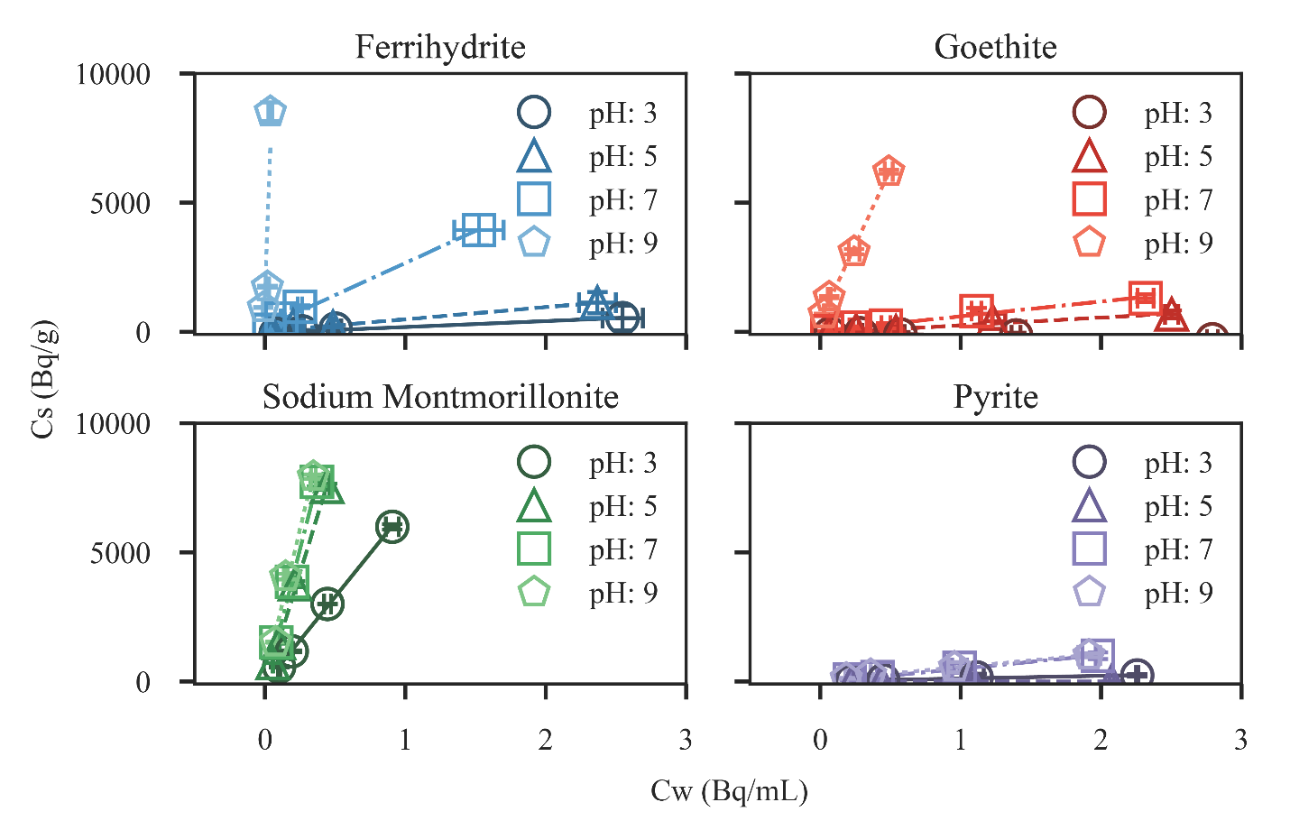**Figure 1:** Isotherm results for the studied minerals. Error bars represent the standard deviation of the triplicate measurement. Fit lines’ slope matches the measured Kd values reported in Table 1.

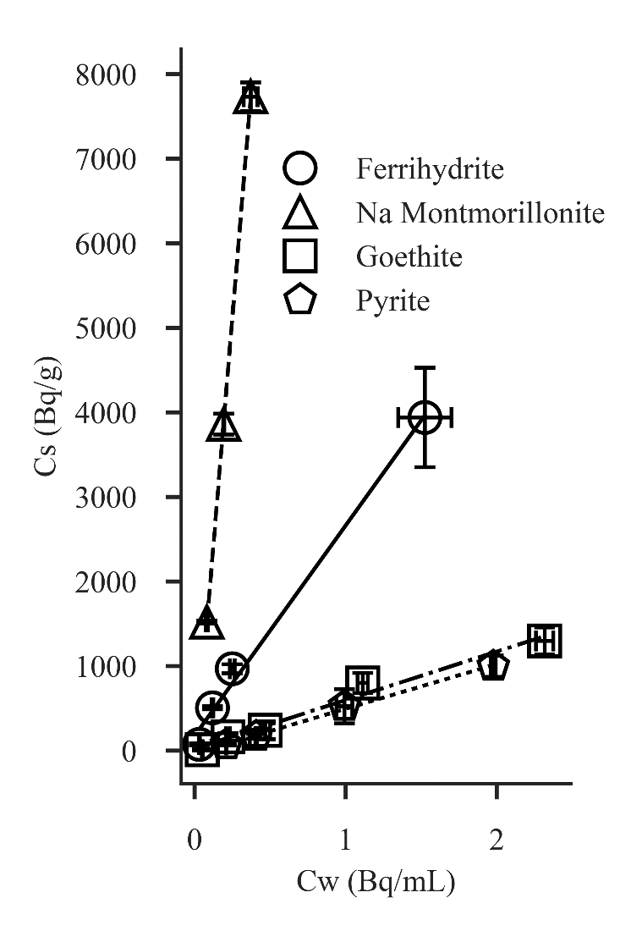

**Figure 1:** Sorption isotherm results for pH 7. Error bars represent the standard deviation of triplicate measurements, and fit lines’ slope the reported Kd values in Table 1.

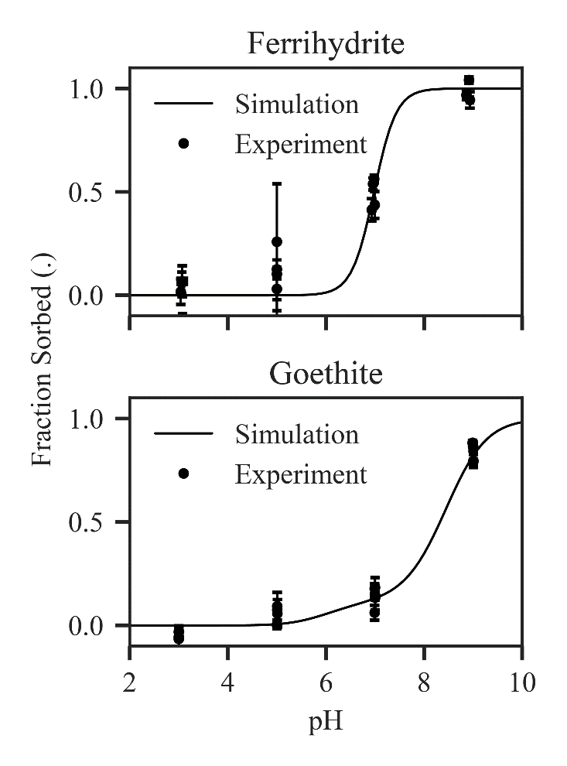

**Figure 2:** SCM results compared against experimental results for ferrihydrite and goethite. Error bars on data points represent standard deviation of triplicate experimental measurements.

SCM stuff: this can go in your thesis

Several studies examine sorption of Ra to iron (hydr)oxides, including ferrihydrite and goethite, and report Kd values (or sufficient data for calculation) (table S2).9,11,17,18

Radium isotopes are also used as naturally occurring environmental tracers. The mass balance of Ra isotopes in estuarine/near shore systems can provide estimates of subterranean groundwater discharge (SGD).31 This method matches well with other SGD measurements, but is unable to resolve groundwater behavior within estuarine systems; non-conservative mixing and retardation may occur in these zones owing to sorption or fluctuations in pH, salinity or redox state.9,32 In addition to its use as a groundwater tracer, Ra has also been identified as a marker for historic spills associated with hydrocarbon extraction.7 This is possible if the Ra isotopic signature of produced water significantly differs from that of local groundwater, which is typical in many hydrocarbon bearing formations.33 Successful implementation of this method requires a comprehensive accounting of Ra fate in groundwater, as transport may be significantly non-conservative due to mixing of the highly saline, often anoxic waste waters with shallow, oxic, low salinity groundwater.

as providing constants and reactions to constrain Ra sorption. It also highlights areas in need of additional work to better quantify these transport processes.